5.June 2022
Ceil Climbing Hackster
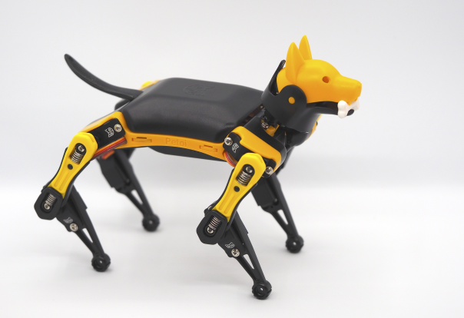

Pitch: Bittle is a open source programmable quadruped robot kit. This article shows new interesting learning capabilities stretching boundaries

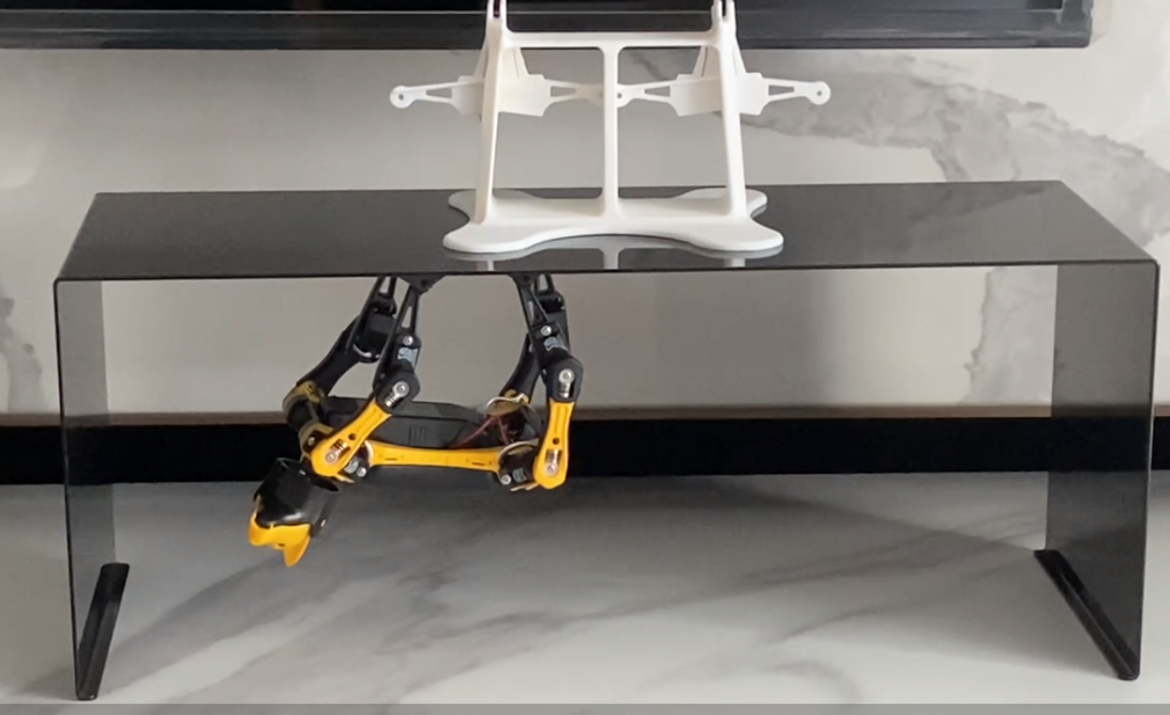
Bittle is a open source programmable quadruped robot kit suitable for STEM, new develoopments, and in general multi-DOF robot design and control applications development. Explanations, instruction are continually updated as well as new application details: a starting page to deep into understanding the versatility of this smart dog can be found at www.petoi.com/
It is worth to remark that it is the 2. most successful project in Arduino over the last 3 years, being Arduino Uno board the first one. https://create.arduino.cc/projecthub/petoi/opencat-845129?ref=platform&ref_id=424_popular___&offset=8
After Arduino Uno board Bittle follows on Arduino platform and it is not by chance.

I bumped into Bittle after long searching for a sophisticated robot open source, fairly priced with more than 6 degrees of freedom, ideally working on Arduino platform and ready to implement python scripts. My goal is to I aim at controlling it through ROS2 and this will be my goal in the next months.
As for today I could successfully go through the bumpy road of having it under control in terms of software understanding and hardware design. Of course due to Petoi team design continuous improvements and extensions, it is quite challenging to keep pace with all new features emerging. The last outstanding one being the User Interface (UI) to adjust each single motor and toggle various features, e.g. gyro. Of course coupling Bittle with a Raspberry Pi is also something which stretches creativity limits a step further.

This essay focuses on showing the implementation of ‘Bittle climbing’ in which Bittle climb a structure, while turning itself upside down. Additionally the smart dog carries out checks and change postures while staying in this odd posture. Hereafter the video showing the outcome after few failed attempts: https://www.youtube.com/watch?v=cWgpqxFAHh8
A app allows to control Bittle also from a mobile phone with instruction available at:
https://docs.petoi.com/app-guide

OpenCat.ino is the main control module and can be found at following link:
https://github.com/PetoiCamp/OpenCat/tree/main

The code related to this essay, including drawings, pictures are in my repository:
https://github.com/GabriIT/bittle

Bittle specifications, multiple sensors, hardware and software basics can be found in the instructions manual and further details at Petoi github address https://github.com/PetoiCamp/OpenCat

The learning curve is slightly steep in the early stage, but the available forum and timely replies by petoi team helped a lot in making it a viable solution.
Few months after purchaising the kit I felt that for STEM education it is likely to be indeed a pioneer platform in many aspects. The only draw-back are materials used: it is common PC-ABS, quite sufficient for simple toys, but not enough in my opinion for impact, stiffness requiring applications. For a more industrial use a more sofisticated material selection is required. I already addressed the issue with petoi team and new solutions are under investigation.
Working in Arduino IDE, after opening the main Opencat.ino, you can open also the directory src and find various modules. One of them is InstictBittle.h

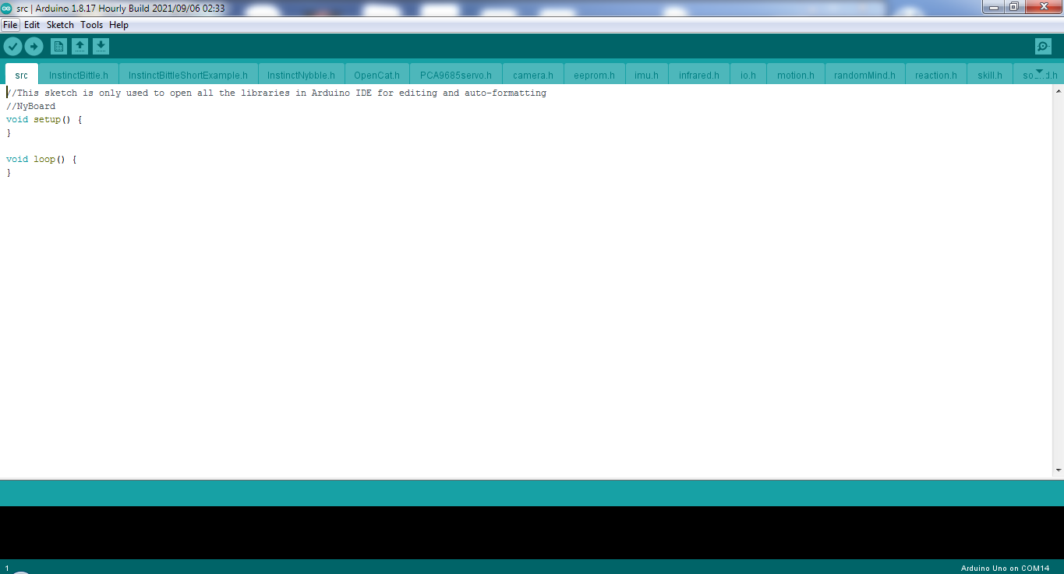
Fig. 1 Modules in src folder including InstictBittle.h

It contains many postures and behaviours already developed by Petoi team. You can play them or modify them. Also the challenge I am addressing today is already in the list with name ‘cc’ (see fig below). However there are many factors involved which prevent it from working as desired and a re-making or fine-tuning is required. The steel structure dimension at first, the firction of the floor, the magnets added at each leg toe: all these elements lead to a new design of the full behaviour frame by frame. A frame is the single posture Bittle is at each outgoing signal from the PCB. In total there are 16 signals though the DOF are 8 plus the head. In total 9 servo-motors to control.
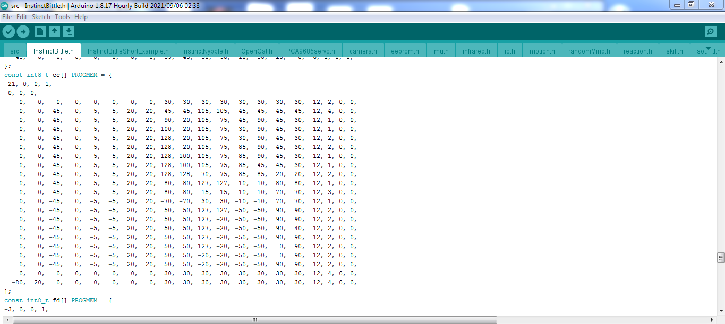
Fig.2 InstictBittle.h – many behaviours and postures are already developed ready for use

As for hardware preparation there two important steps to do:
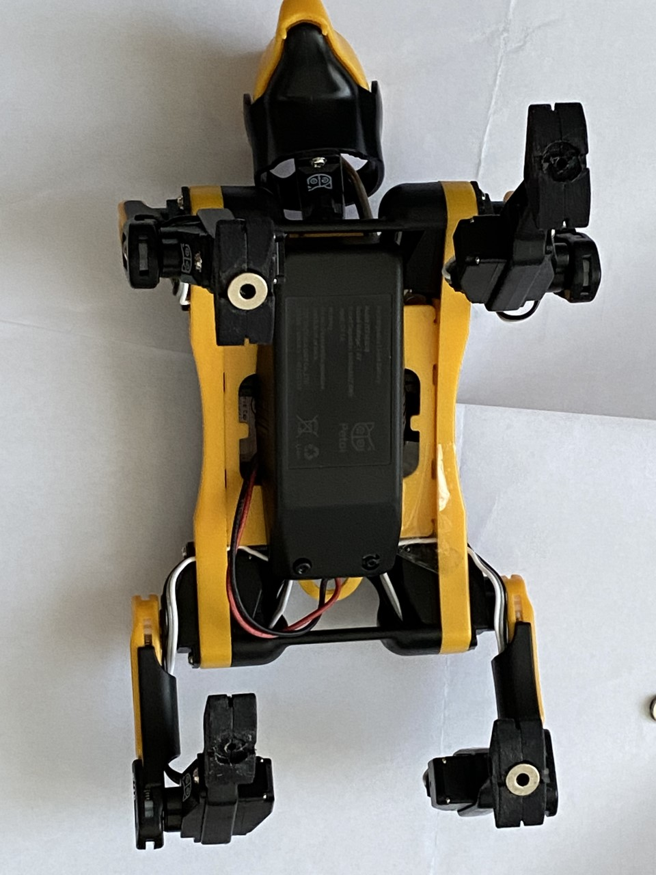
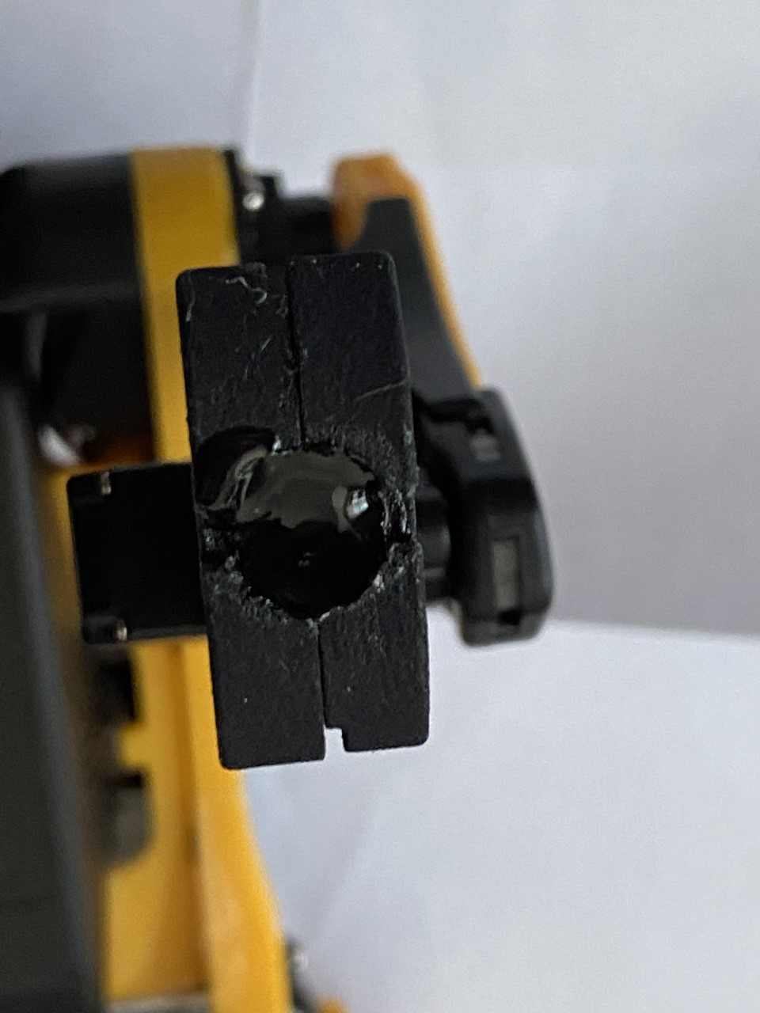
1 - print out the 4 toes to to be able to mount a magnet: each toe is made of two identic parts: in total you need to 3D print 8 pieces, 10 for safety sake if something goes wrong
you need 8 magnets diameter 8 mm, thickness 3 mm and internal hole 3 mm

2 - monting the magnet on each toe and set strong adhesive to assure good bonding
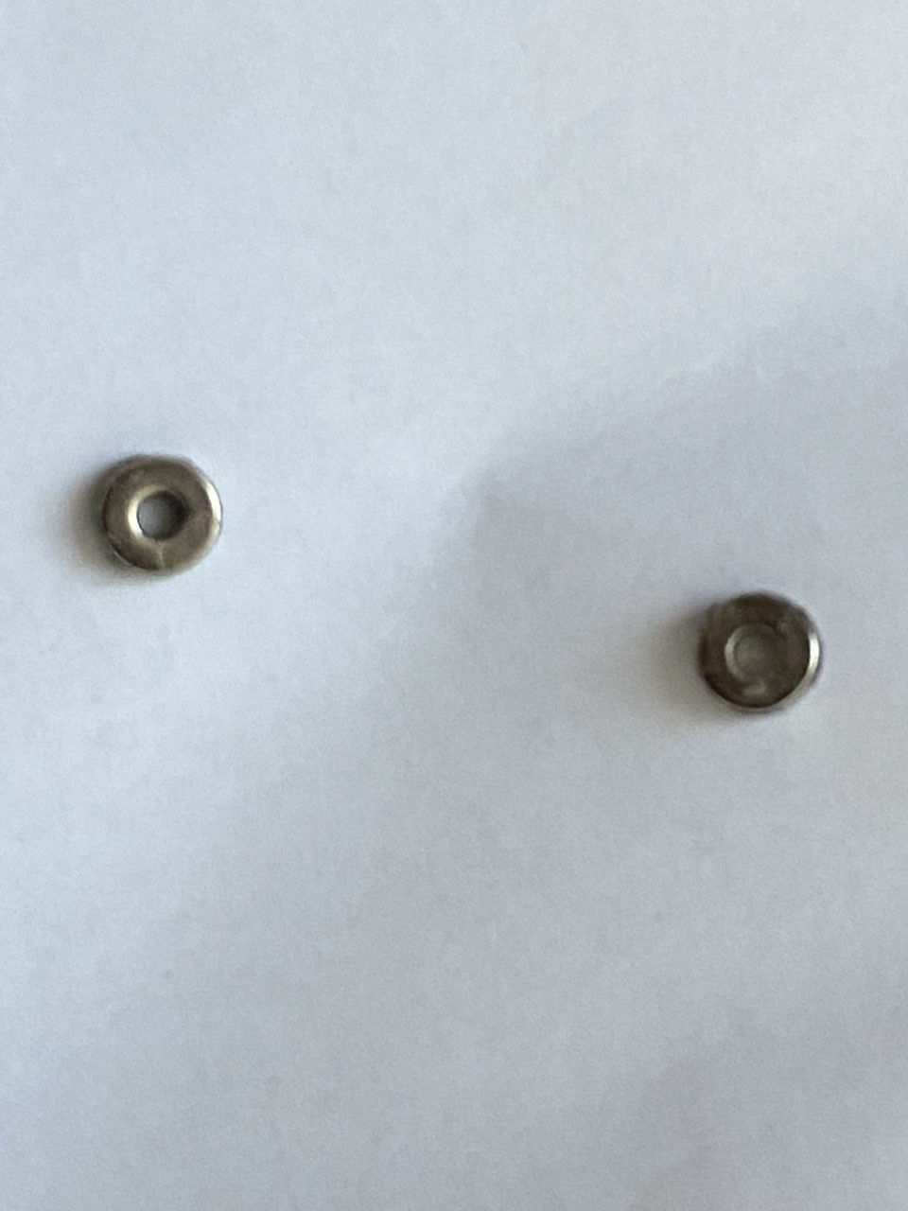
after mounting the two toe parts you set adhesive on the resulting seat where the magnet can be set. I use quick-bonding 602 class adhesive, after failing with 502. Please make sure that mounted toes are still free to rotate against the Bittle leg. It is important to assure Bittle can adapt effectively when magnet-bondin toes to the steel platform

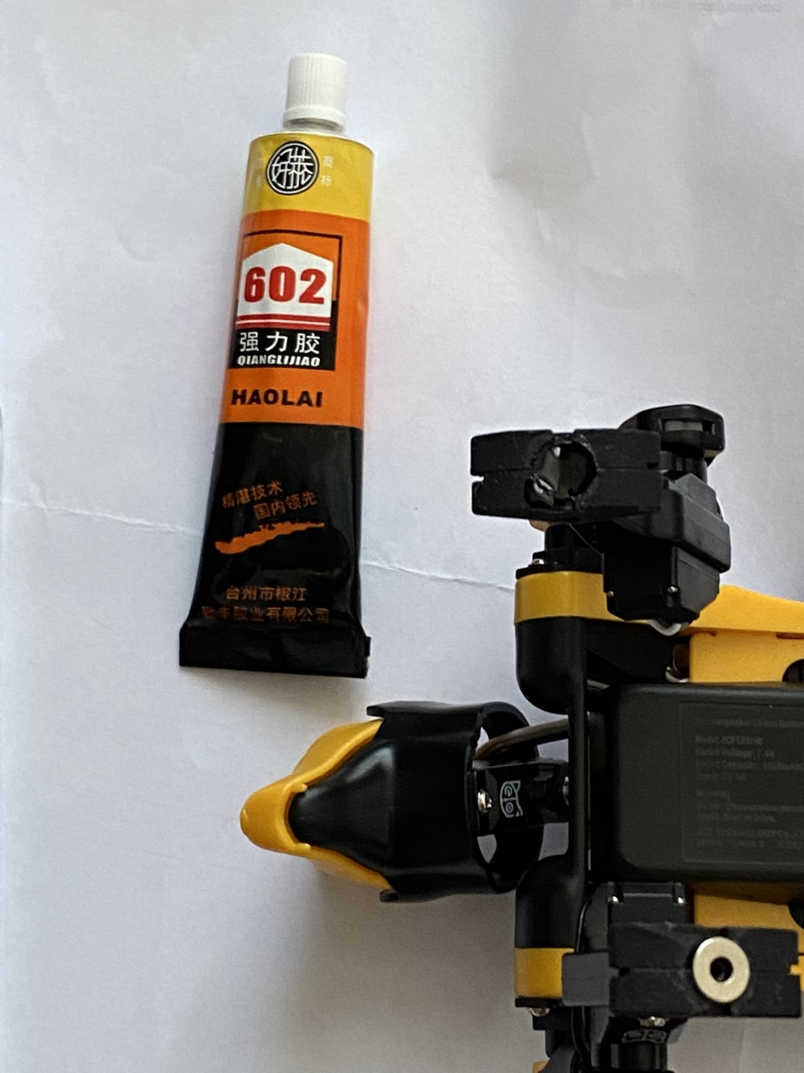

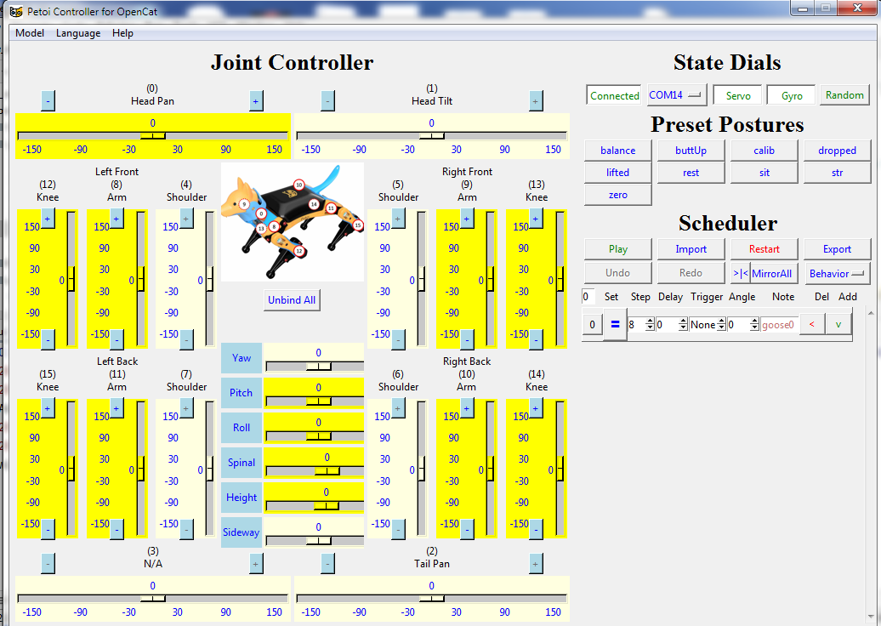

Fig. 3 the newly developed user-friendly UI for optimization of single frames and signle servo-motors

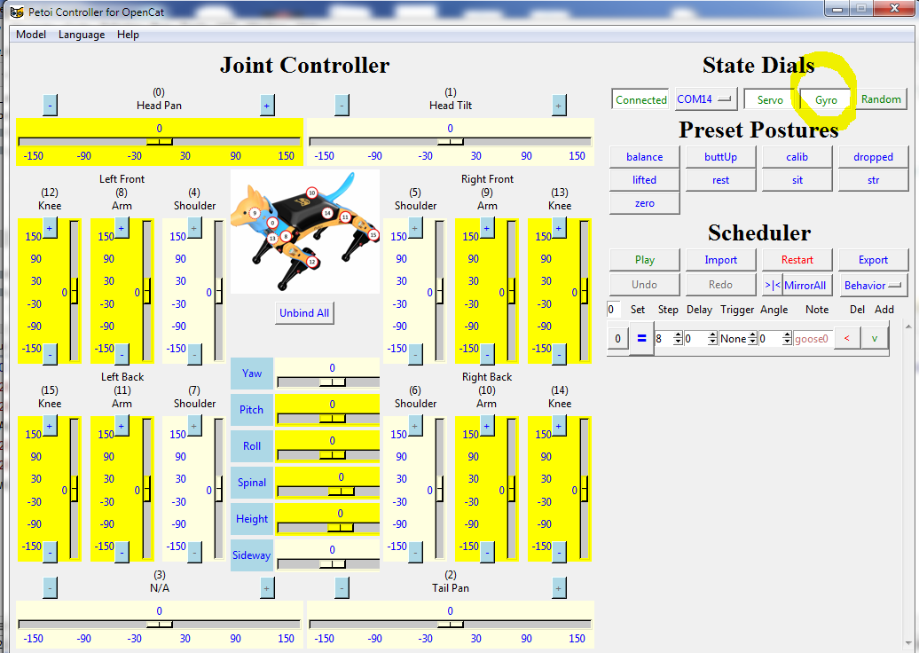

Fig 4 Gyro is set ON as default. Other switches are available and can be easily toggled

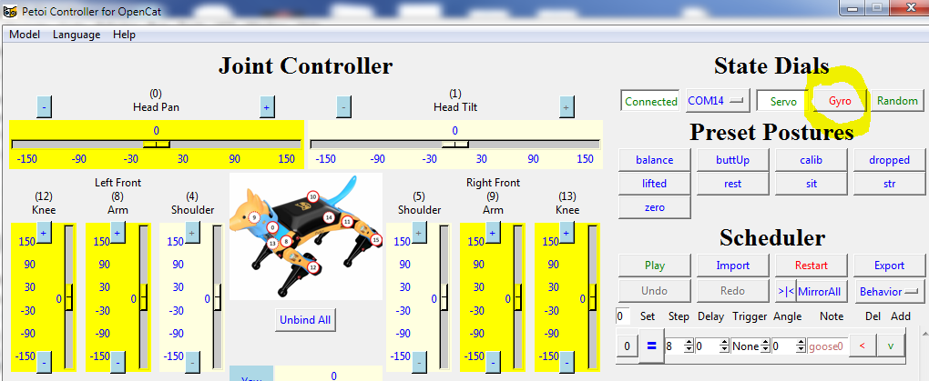
Fig 5 Gyro is set off – to prevent Bittle to follow procedure of turning up when laying on the back

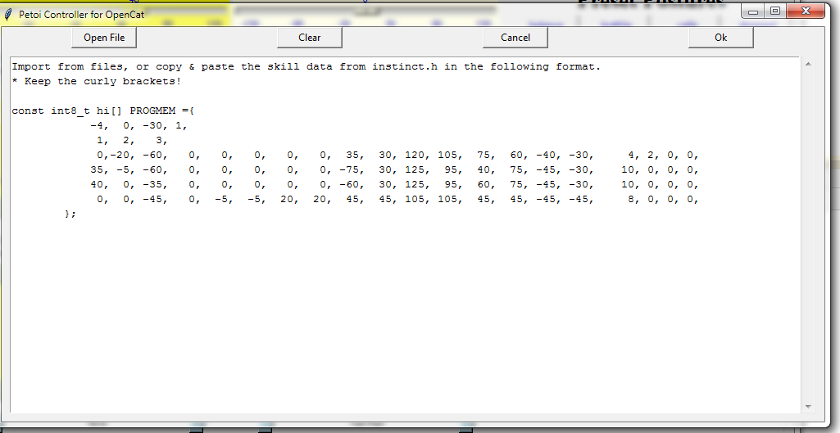
Fig. 6 After clicking Import on UI this windows opens and allow to set the each motors and each desired frame

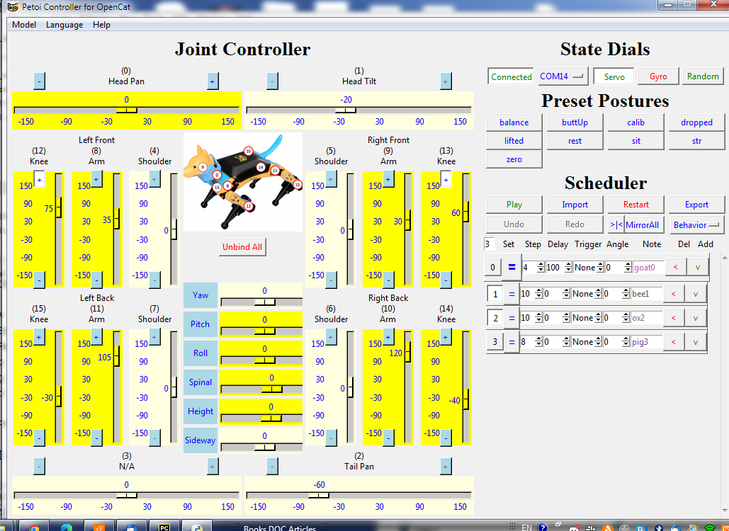

Fig 7 frames are imported on UI for further optimization

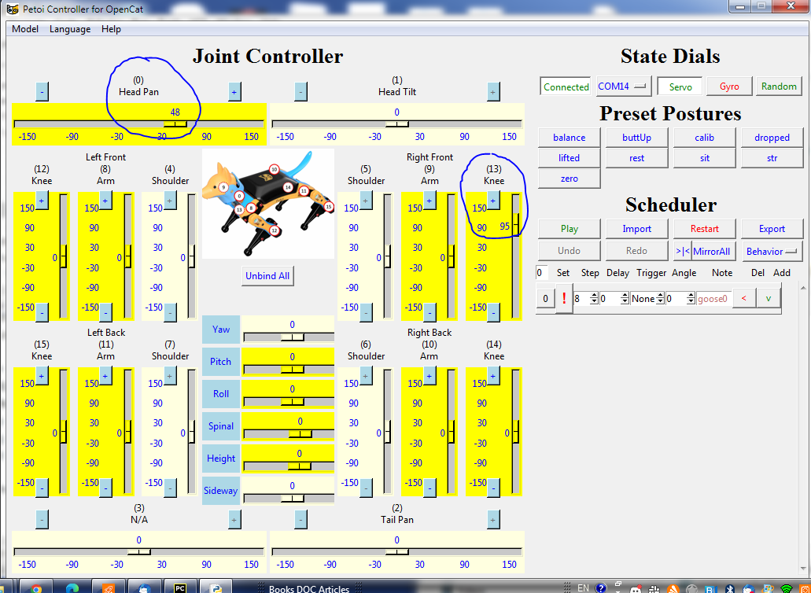
Fig 8 servo motors 0, head and 13, knee positions are adjusted through User Interface (UI)

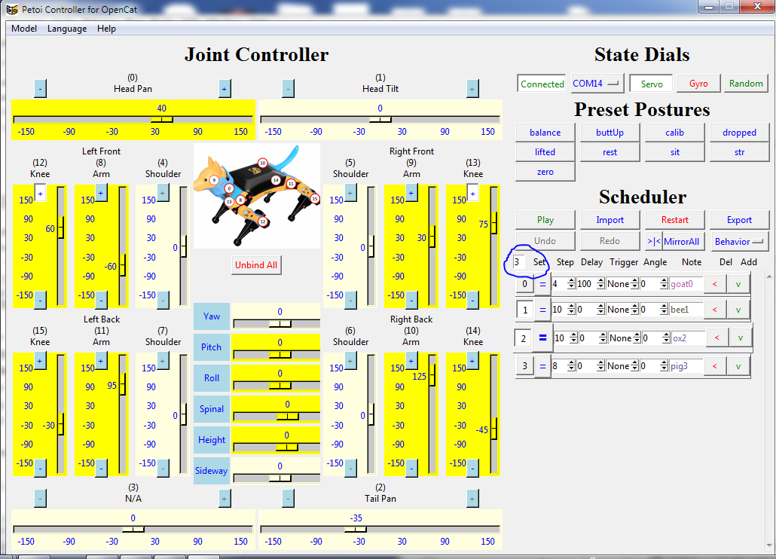

Fig 9 after importing a frame sequence, a number of loops repeating the sequence itself can be set. In the above example is set to 3.
After optimizing the frame sequence, motors setting ‘Export’ allows to export it into a file text. From there you can play as you like: loading it on python or adding it into InstinctBittle.h

Being the toes free to rotate it is key to assure that they are flat, parallel to the steel platform before each leg stretches to bound with the platform itself through the inserted magnet. After repeated failures, I improved my code by adding few frames to force the toe to slightly touch the platform surface and lead it smoothly to be parallel to the plane before the leg full contact works. I think this is the most challenging step.
The rest of coding is quite sequential, based on the desired postures you like during the process.
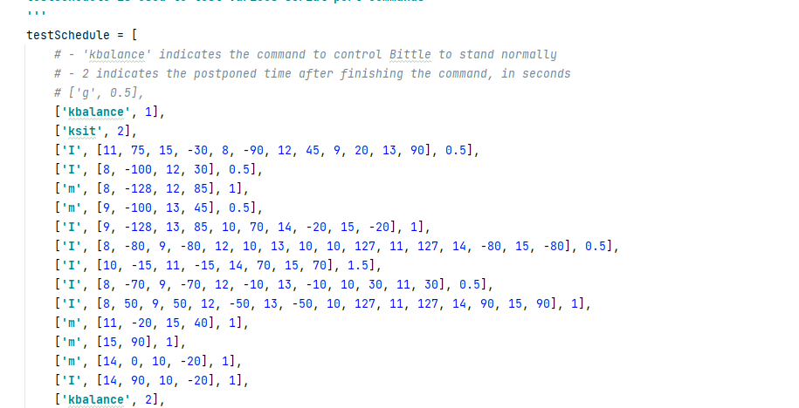
Fig 10 the final code for climbing in python

You can view the repeated attempts and result on YouTube at following link:
--------------------------------------------------------

Finally a tip: the lively forum is a very useful place to look for problems people faced in the past or for asking questions in case of new unexpected troubles, explanations or insufficient understanding
https://www.petoi.camp/forum

The next challenge will be integrating into a ROS2 environment and enabling ML functions. I look forward to forthcoming development by petoi team as well as ML edging features.

Did you find this article useful? Let me know what you think by leaving a comment.

Links list:

-Bittle, my repository: https://github.com/GabriIT/bittle
-App instructions : https://docs.petoi.com/app-guide
-Bittle, User manual: https://bittle.petoi.com/
-Petoi repository Opencat: https://github.com/PetoiCamp/OpenCat
-Petoi repository Opencat 2.0: https://github.com/PetoiCamp/OpenCat/tree/main
-Youtube video: -----------------------

